

**Project Requirement and Design Document**



chhatrala, Riten- [rchhatrala@hawk.iit.edu](mailto:rchhatrala@hawk.iit.edu)

A-20385102

Shah, Preyang- [pshah115@hawk.iit.edu](mailto:pshah115@hawk.iit.edu)

A-20385823

Sharma, vivek- [vsharma12@hawk.iit.edu](mailto:vsharma12@hawk.iit.edu)

A-20393036

* **Features:**
* The following will be the features:
* You can select the different dataset for different city.
* You can see the database in tabular format or you can see houses on Google map for which we are using Google API.
* You can see different chart like Line, Stack, Pie, Bar Chart by clicking on view chart option.
* You can filter dataset by Rows, Columns, Query.
* After applying filter, you can export the dataset in CSV or JSON.
* **Requirements:**
* Load the dataset
* Perform data analysis
* Visualize the abstracted data.
* Graphical Representation of data.
* Display property on Location Map
* **Design Documents:**

1. **Class diagram**

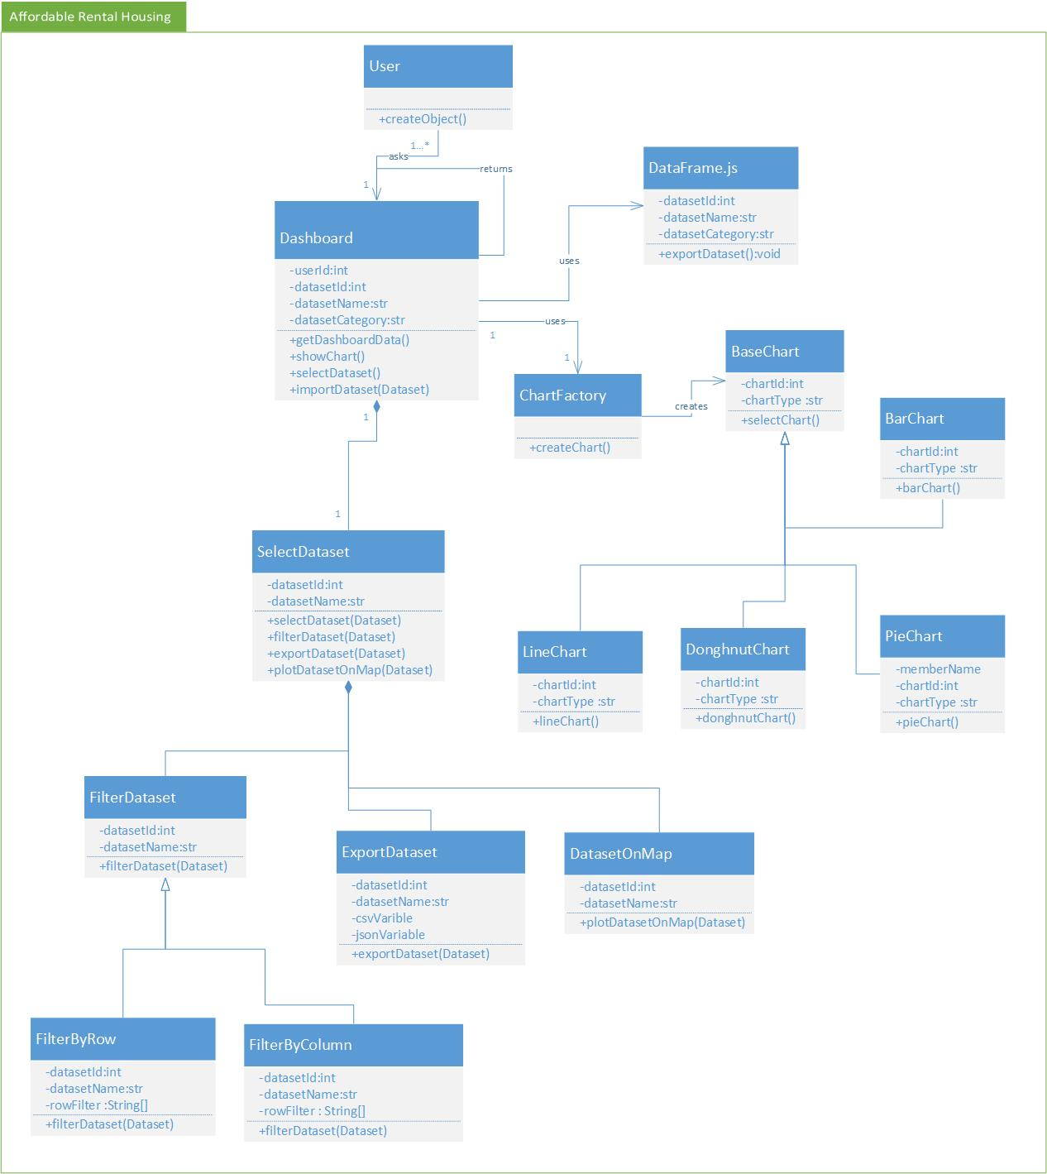

1. **Design Patterns Used:**

* **Singleton Design Pattern:**
* This pattern involves a single class which is responsible to create an object while making sure that only single object gets created. This class provides a way to access its only object which can be accessed directly without need to instantiate the object of the class.
* In our System, Singleton class is Dashboard whose object is created only once. Dashboard class provides a way to access its “only object” which can be accessed directly.

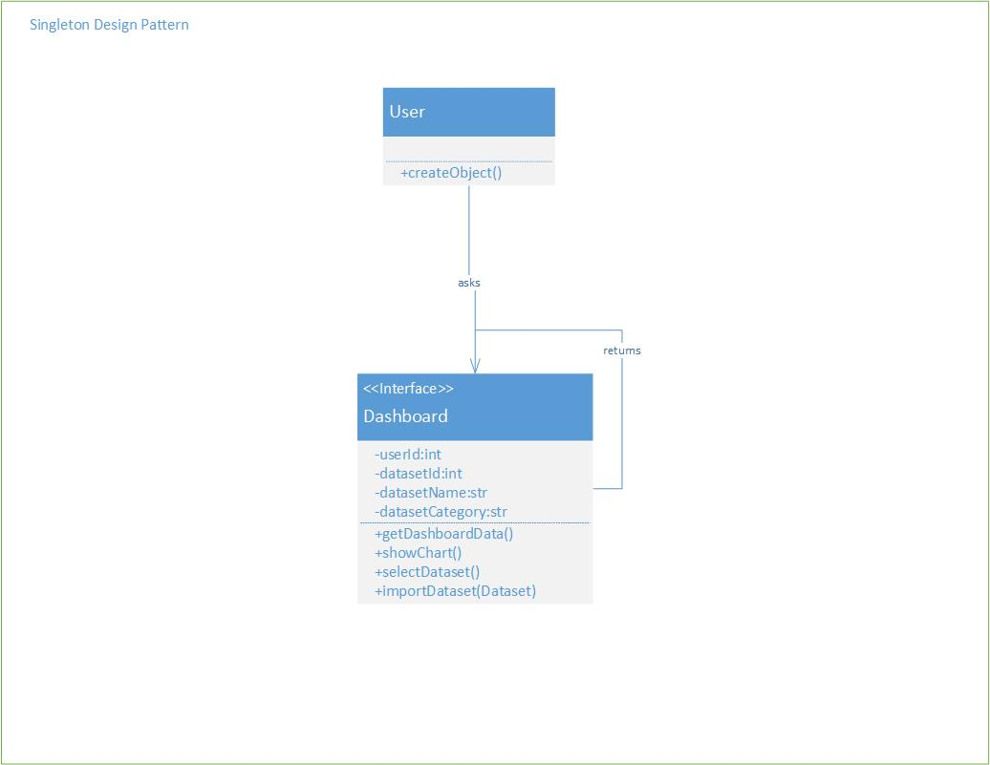

* **Factory Method Design Pattern:**
* The Factory method design pattern is creational pattern which helps creating an object, but let subclasses decide which class to instantiate. Factory method lets a class defer instantiation to subclasses.
* In, Factory pattern, we create object without exposing the creation logic to the client and refer to newly created object using a common interface.
* In our System, chartFactory class has the factory method which calls Chart class and it is abstract class and the classes named PieChart, BarChart, LineChart, DoughnutChart is concrete classes which will implement the method of Chart class.

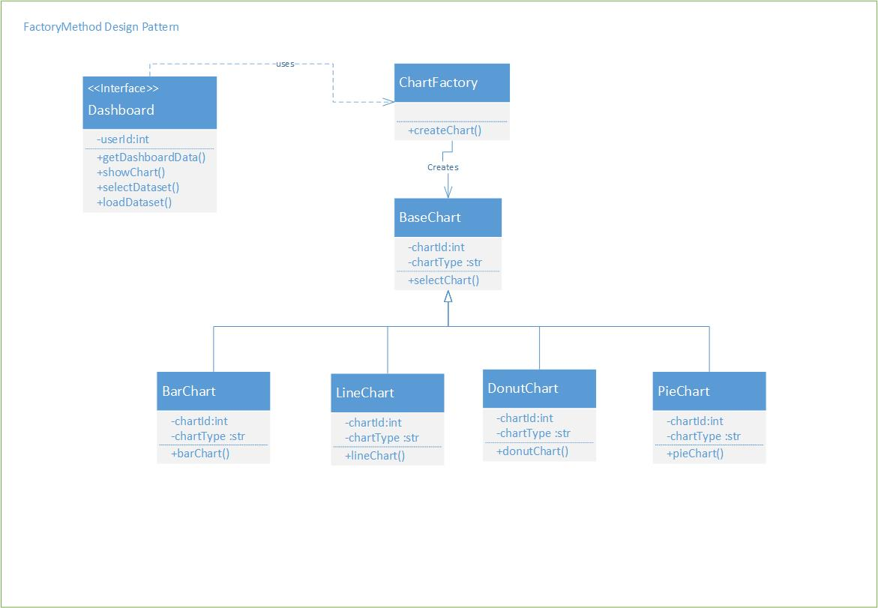

1. **Sequence Diagram :**

* **Display Chart Sequence Diagram**

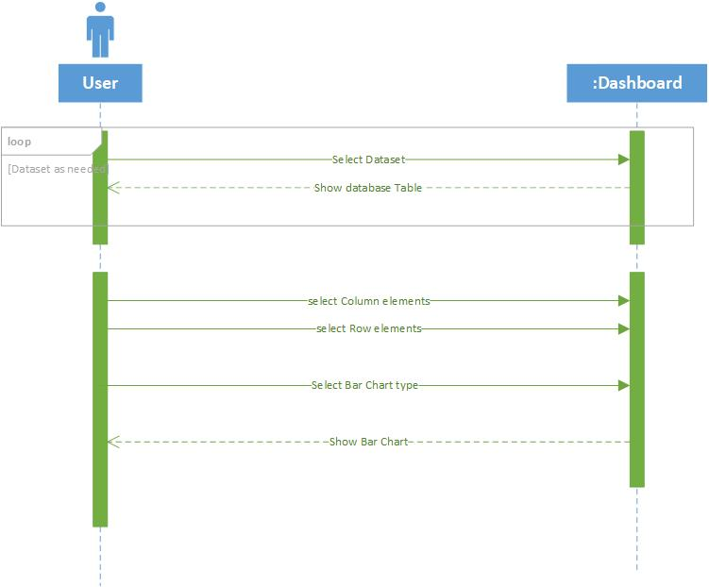

* **Export Dataset**

